Ozone Mapper Profile Suite (OMPS) Sensor Data Record (SDR)
Error Budget

OMPS SDR Science Team
September 08, 2015

Geolocation

Specification
The boresight alignment uncertainty between the nadir instrument interface and the nadir alignment reference shall be less than 160 arcsec (1/4 of a pexel) in both cross-track and along-track direction (1 sigma). The total cumulative boresight alignment shift between the final ground calibration and or-orbit operations shall be less than 500 arcsec (3 sigma, per axis) [1].

Pre-Launch Budget
To be provided.

Pre-Launch Performance
Alignment uncertainty was 90 arcsec per axis (to be verified). Alignment shift, estimated by analysis, was 95 arcsec in azimuth and 222 aresec in elevation.

Post-Launch Performance
Less than 64 arcsec or 1/10 of a pixel.

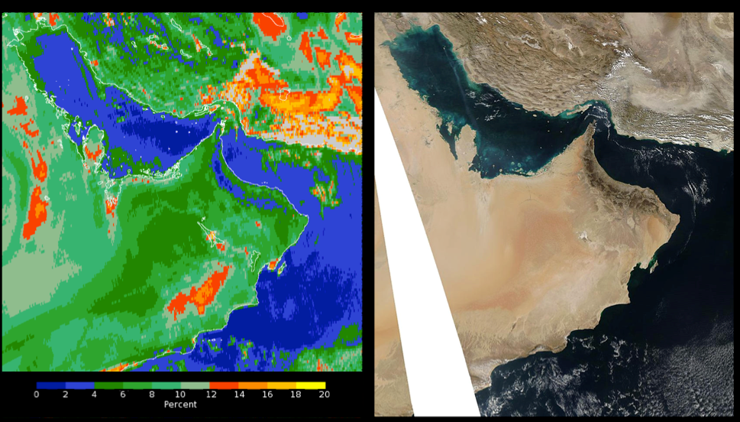

Figure 1: High-Spatial-Resolution Geolocation Comparison. The image on the left shows a false color map of the OMPS effective reflectivity (from a single Ultraviolet channel at 380 nm) over the Arabian Peninsula region for January 30, 2012 when the instrument was making a special set of high-spatial-resolution measurements with 5×10 km² FOVs at nadir. The color scale intervals range from 0 to 2 % in dark blue to 18 to 20 % in yellow. The image on the right is an Aqua Moderate Resolution Imaging Spectroradiometer (MODIS) Red-Green-Blue image for the same day.

Signal-Noise-Ratio (SNR)

Specification
The TC sensor shall meet or exceed the minimum signal-to-noise ratio (SNR) requirement OF 1000 for each wavelength channel over the range of input radiance levels (SS3.2.1.7.1-1) [1]. The NP sensor shall meet or exceed the minimum SNR requirement for each wavelength over the range of input radiance levels shown (SS3.2.1.7.1-3) [1].
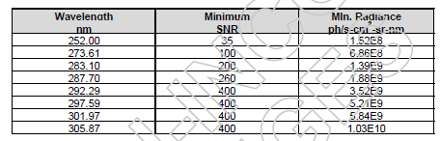

Pre-Launch Budget
Budget for this error is 1000 for NM and 45-400 channel dependent for NP.

Pre-Launch Performance [2]
Instrument | Mode | worst case SNR | Average SNR
NP | radiance | 2892 | 6055
 | irradiance | 2204 | 4723
TC | radiance | 3301 | 3547
 | irradiance | 2698 | 2895

Post-Launch Performance
Meet the specification with margins.

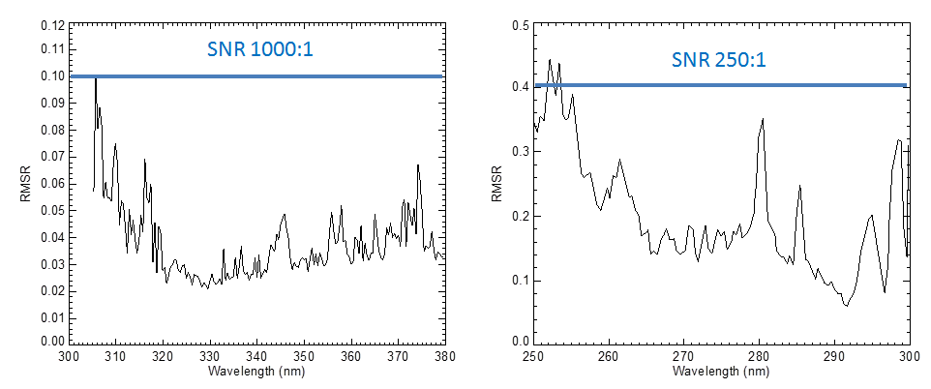
Figure 2: OMPS Nadir Mapper earth view noise as percent of the earth view signal. The root mean square residuals in percent were computed from an Empirical Orthogonal Function Analysis where the six largest patterns were removed. For the NM sensor, shown on the left, the residuals equate to signal-to-noise ratios of better than 2000:1 for wavelengths greater than 320 nm, dropping to 1000:1 at the shorter wavelengths. For the NP sensor, shown on the right, the SNR varies from 550:1 at the longer wavelength to 250:1 for the shortest; spikes correspond to lower signal levels due to solar lines at those wavelengths.

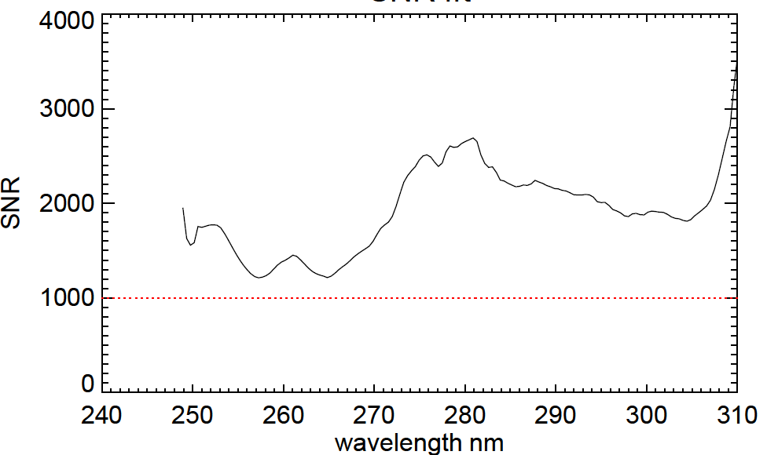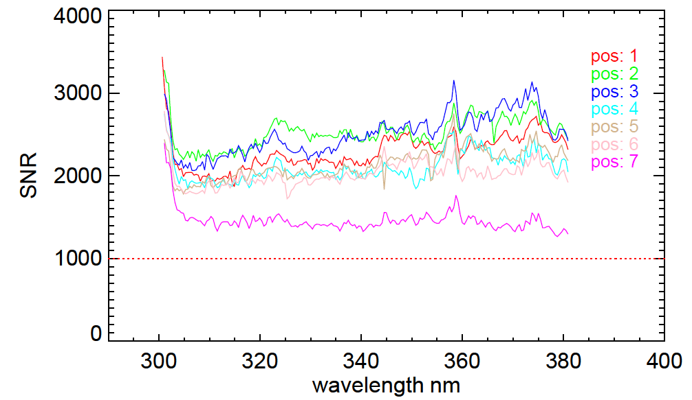

Figure 3: SNR from solar views (working diffuser) for OMPS NP (left) and NM (right). The dotted red line in each figure is the required SNR.

Albedo Calibration

Specification
The wavelength independent radiometric (albedo) calibration uncertainty shall be less than 2%. The wavelength dependent radiometric (albedo) calibration uncertainty shall be less than 0.5% [2].

Pre-Launch Error Budget
Source of Uncertainty | Albedo 1σ Fractional Uncertainty (%)
 | λ - independent |  | λ - dependent
 | NP | TC | NP | TC
Requirement | 2.0 | 2.0 | 0.5 | 0.5

Pre-Launch Performance
Source of Uncertainty | Albedo 1σ Fractional Uncertainty (%)
 | λ - independent |  | λ - dependent
 | NP | TC | NP | TC
OMPS NPP RSS Total | 1.653 | 1.717 | 0.426 | 0.497

Post-Launch Performance

Source of Uncertainty | Albedo 1σ Fractional Uncertainty (%)
 | λ - independent |  | λ - dependent
 | NP | TC | NP | TC
OMPS Percent Uncertainty | ≤ 2.0 | ≤ 2.0* | ≤ 0.5 | ≤ 0.5

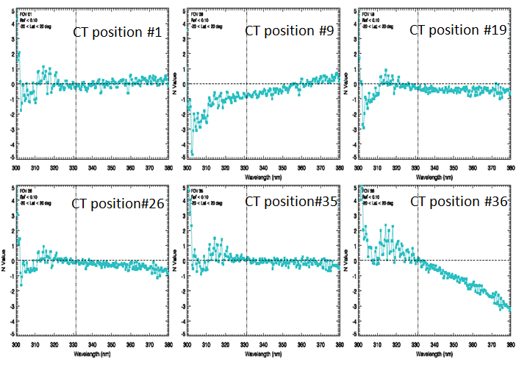

Figure 3 NM albedo uncertainty meets the requirement for the most of the channel. Exception is cross track position #35 on wavelength > 360 nm where the uncertainty varies from 2 - 3% as show in the following figure. Soft calibration on the EDR level is being implemented to eliminate this residual error.

Nonlinearity

Specification
The system nonlinearity shall be less than 2% full well. Uncertainty of system nonlinearity shall be less than 0.5% [2].

Pre-Launch Budget
Budget for nonlinearity is 2%. Budget for nonlinearity uncertainty is 0.5%.

Pre-Launch Performance
System nonlinearity is less than 2%. Uncertainty in nonlinearity is 0.1% [2].

Post-Launch Performance
To be verified via EDR performance, including soft calibration.

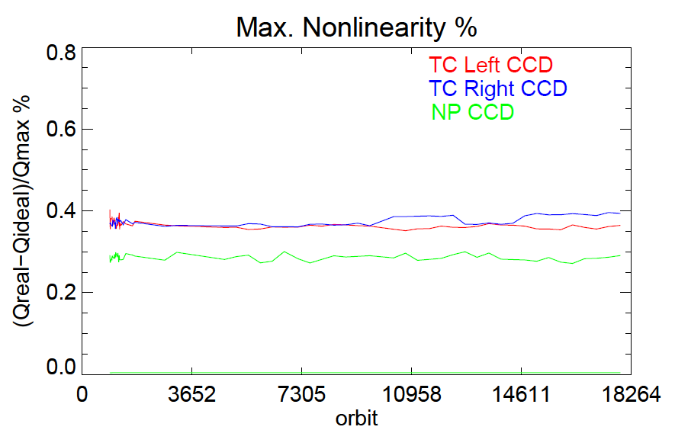

Figure 4: Maximum nonlinearity on-orbit is ~0.4%, meeting the specification of 2%. Uncertainty in nonlinearity is 0.2%, meeting the specification of 0.5%.

Sensor Response Uniformity (intra-IFOV)

Specification
The accuracy of the calibration at one pixel with respect to another pixel should be 1% or better (SS3.2.1.19.1-1).

Pre-Launch Budget
The accuracy of the calibration at one pixel with respect to another pixel should be 1% or better.

Pre-Launch Performance
The sensor response uniformity (intra-IFOV) will not be directly verified by test. OMPS meet this requirement by using an integrating sphere, which produces an essentially flat field. That means that when two different pixels are calibrated, they look at the same source with the same intensity. The accuracy of the calibration with this source is driven by its stability. The integrating sphere stability is 0.6% peak-to-peak or better. Thus, the relative response knowledge is better than 1%.

Post-Launch Performance
The sensor response uniformity (intra-IFOV) will not be directly verified by orbital data. A statistical method is being used to study the pixel-to-pixel variation. This method requires a large set of high resolution earth view data over the Greenland. This study is currently undergoing and more high resolution data is being collected.

Stray Light

Specification
Response to signal shall be less than < 2%.

Pre-Launch Budget
Budget for this error is 2%.

Pre-Launch Performance
A summary of stray light contributions to signal and overall uncertainty in radiance calibrations [2].

 | NP |  | NM
 | Stray Light (%) | Residual Uncertainty (%) | Stray Light (%) | Residual Uncertainty (%)
Radiance | 2.75 | 0.242 | 0.5 | 0.043

Post-Launch Performance
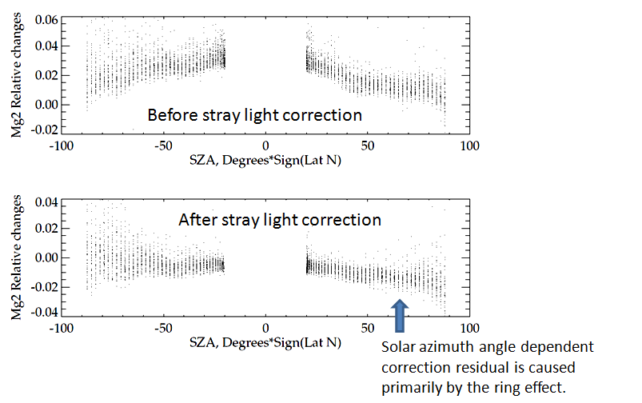
Figure 5 Post-launch validation uses change in EV Mg II index that reflects stray light correction. Mg II index varied with SZA before the NP stray light correction. Stray light contamination caused up to -1.0 ~ 5.0% errors in EV radiance. The errors are within ±2% for the most of the channels after stray light correction was applied [3].

Wavelength Registration

Specification
Uncertainty of band center wavelength shall be less than 0.02 nm.

Pre-Launch Budget
Budget for this error is 0.02 nm.

Pre-Launch Performance
Ground wavelength calibration uncertainty is <0.01 nm (NDR3.2.1.2.3.1-4 [4]).

Post-Launch Performance
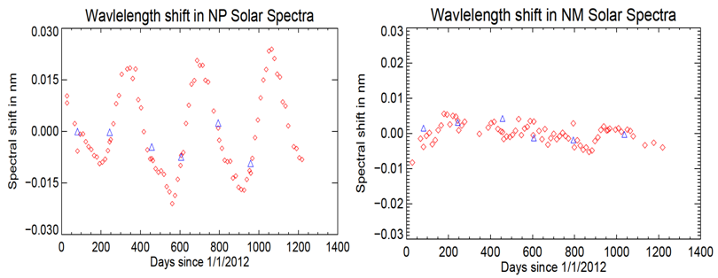

Figure 6 Orbital wavelength change is < ±0.01 nm for NM and ±0.02 nm for NP.

Intra-Orbital Wavelength Stability

Specification
Intra-orbital wavelength stability was not specified, but the EDR sensitivity expects this error to be less than 0.02 nm.

Pre-Launch Budget
Budget for this error is 0.014 nm.

Pre-Launch Performance
During the OMPS Integrated Sensor Suite (ISS) thermal balance testing, temperature cycles were imposed that are representative of variations expected on orbit, and the spectral shifts were recorded. 5% of these data were then used to train Singular Value Decomposition (SVD) model, which was then validated using the remaining 95% of data. The SVD model then predicts that on orbit shifts to be less than 0.01 nm.

Post-Launch Performance

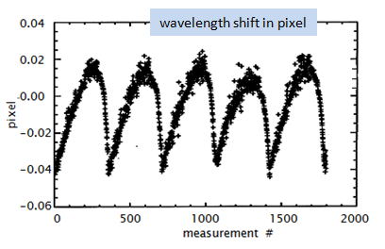
Figure 7 Intra-orbital wavelength shift is smaller than 0.04 pixels that is equivalent to 0.016 nm.

Irradiance uncertainty

Specification
The absolute accuracy for laboratory radiometric measurements between 250 nm and 380 nm shall be ≤7% for irradiance (SS3.2.1.11.1.1-1) [2].

Source of Uncertainty | Irradiance Absolute 1σ Fractional Uncertainty (%)
 | NP | NM
Requirement | 7.0 | 7.0

Pre-Launch Budget
Budget for this error is 7% for both NP and NM [2].

Pre-Launch Performance [2]
Source of Uncertainty | Irradiance Absolute 1σ Fractional Uncertainty (%)
 | NP | NM
OMPS NPP RSS Total | 3.499 | 3.194

Post-Launch Performance [3]
Source of Uncertainty | Irradiance Absolute 1σ Fractional Uncertainty (%)
 | NP | NM
OMPS NPP RSS Total | 7.0* | 7.0
*see figure 8 for explanation.
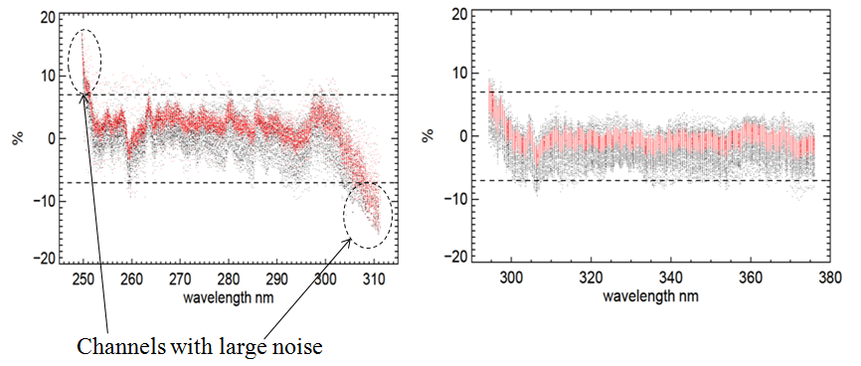
Figure 8 Most channels meet the requirement. Exception is the NP noise channels 250-250 nm and 306-310 nm where uncertainty slightly exceeds the requirement of 7%.

References

BATC, OMPS SYSTEM DEVELOPMENT for the Ozone Mapping and Profiler Suite (OMPS) Feb. 11, 2009

BATC Systems Engineering Report, OMPS FM1 Nadir Sensor Pre-Launch Radiometric Calibration Uncertainties, August, 15, 2008

Fuzhong Weng and OMPS SDR team, Delta Review for SNPP OMPS SDR Earth View Products, August 17, 2015

BATC, OMPS Nadir Performance & Calibration Test Readiness Review (TRR), December 15, 2006

